Java IO Lab

SubmitedBy

Mithlendu Kumar

QN1

wap to read text file and count the number of vowels in it

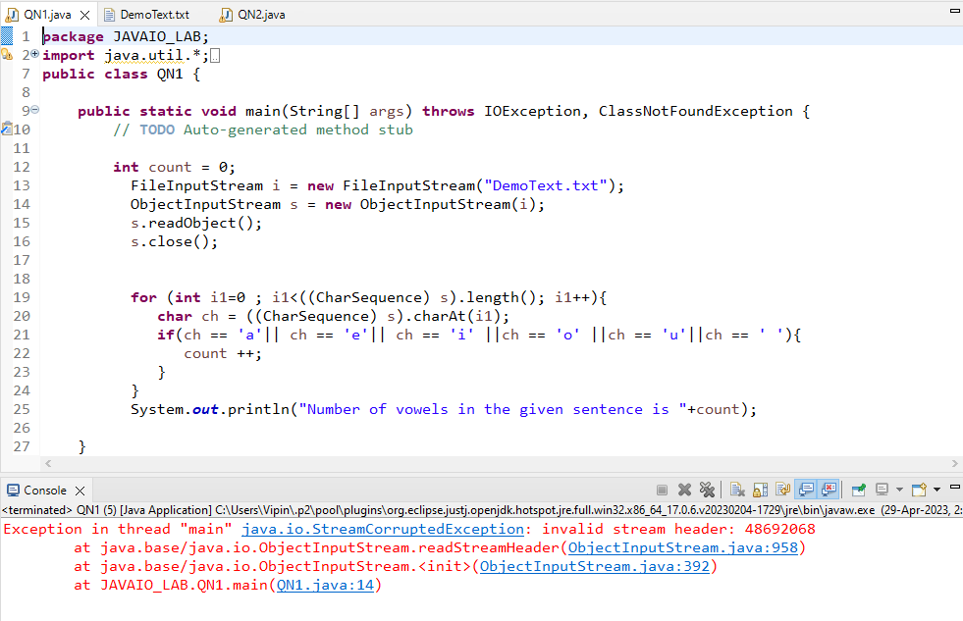

QN2

 wap to copy content of one file to another

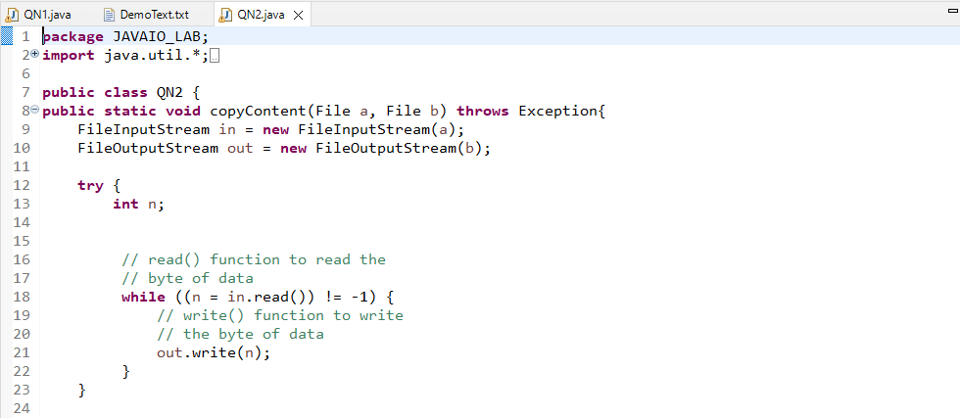

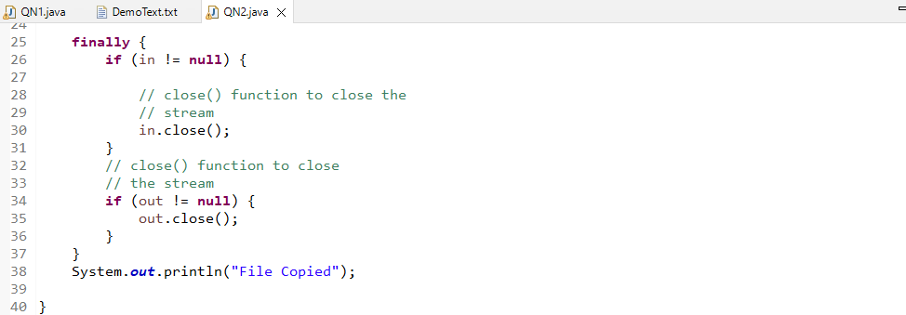

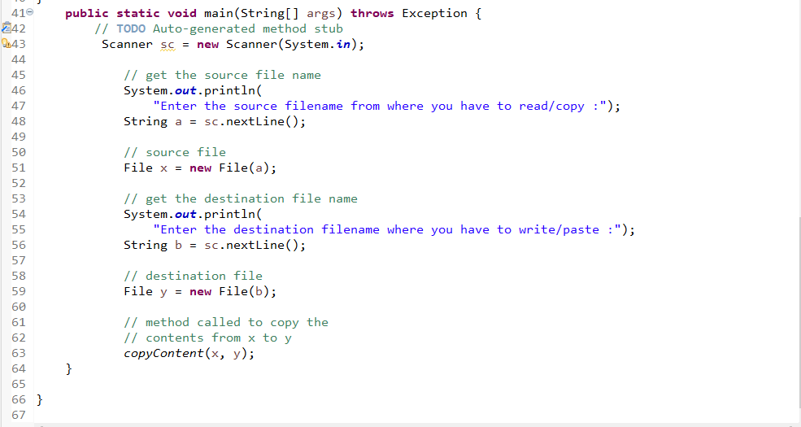

Output

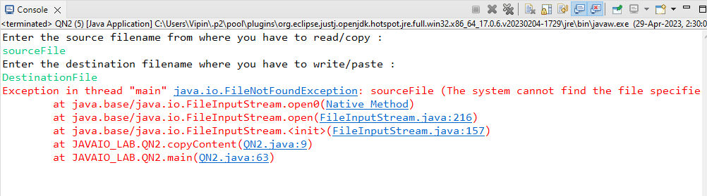

QN3

 wap to read csv file and display in formatted way hint use scaner class split method

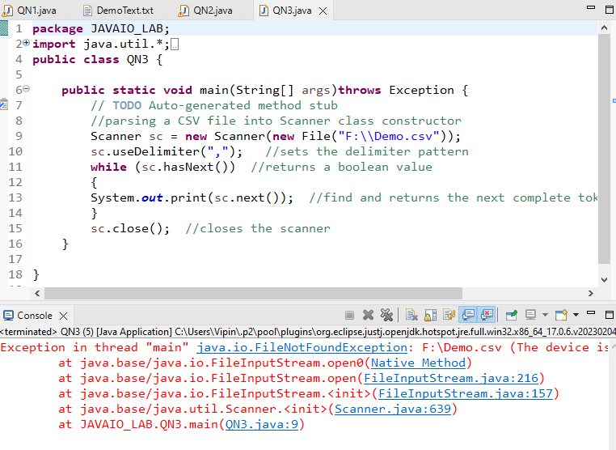

QN4

 wap to list file in directory

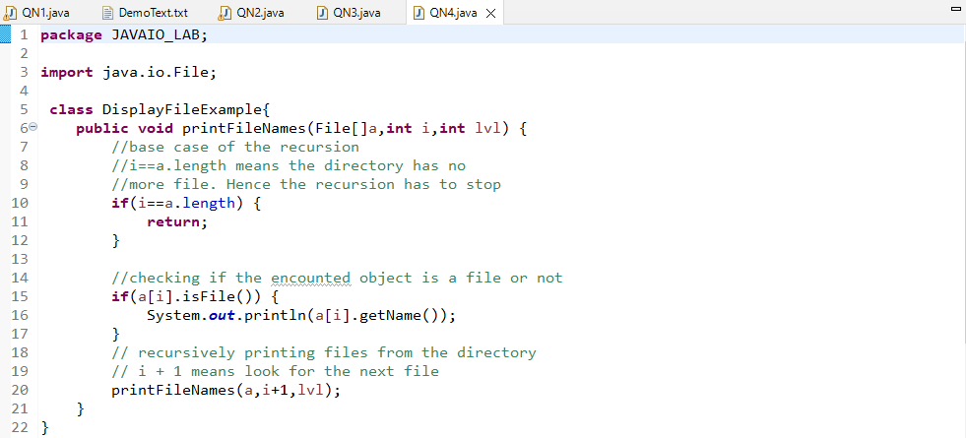

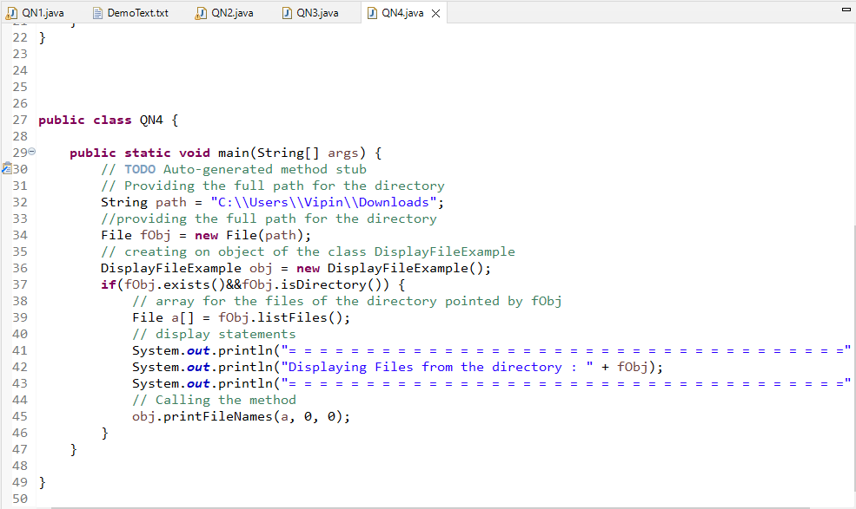

Output

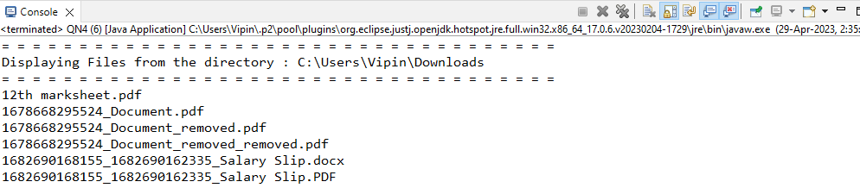

QN5

1 Wap to define a class for employee having fields as empno ,name and addresss.  
       Ask employee details from user using scanner in input method .  
       Display details using display method .  
      Write whole object data to file Employee.dat .  
      Read employee data from file and display it on console

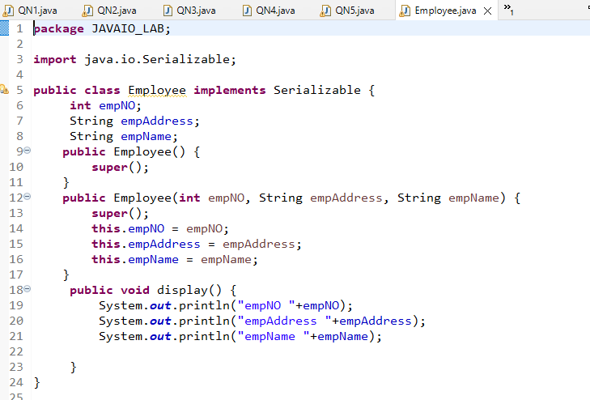

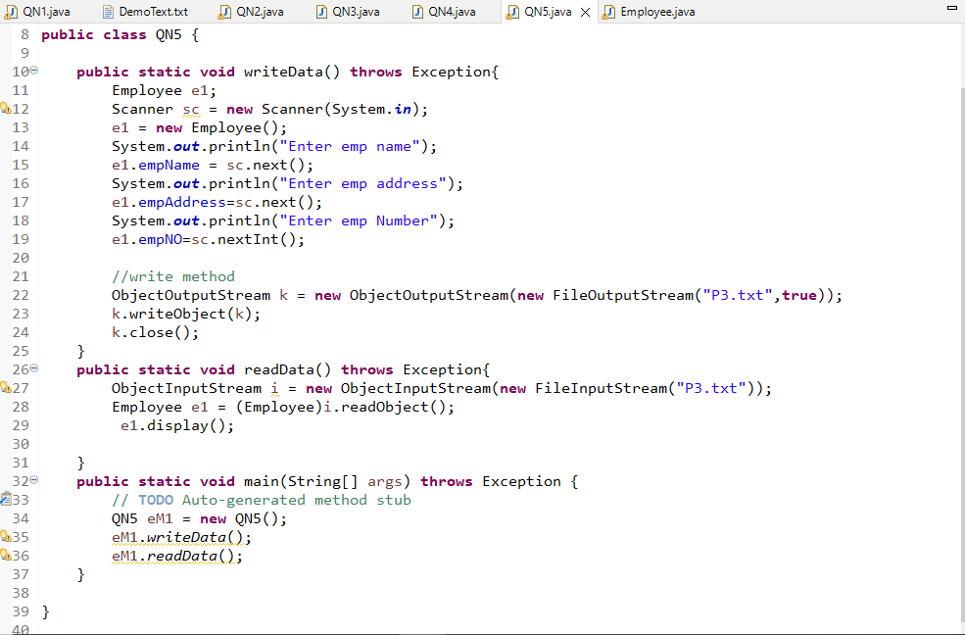

Output

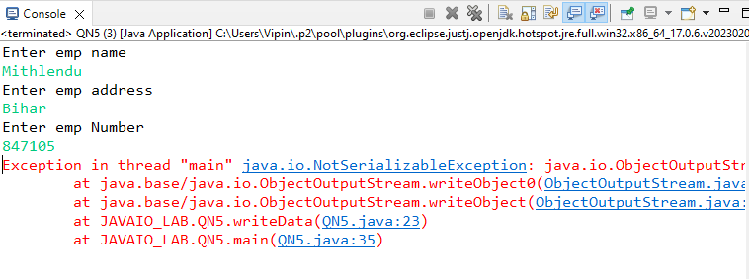

QN6

 create desktop  application for library mgt system  
  
define class book having fields like bname ,aname ,price and get method and display;  
  
define other methods like  
    writeToFile()  
  readfromFile()  
  searchfromFile()  
  
In main design menu driven application  
 1) store data to file  
 2) read data fom file  
 3) search data from file  
 4) exit

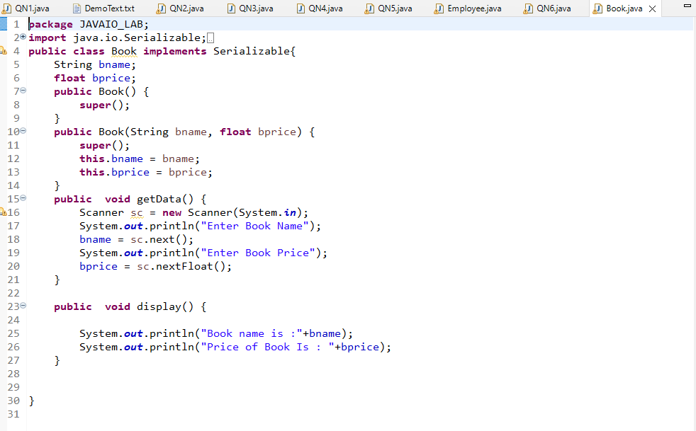

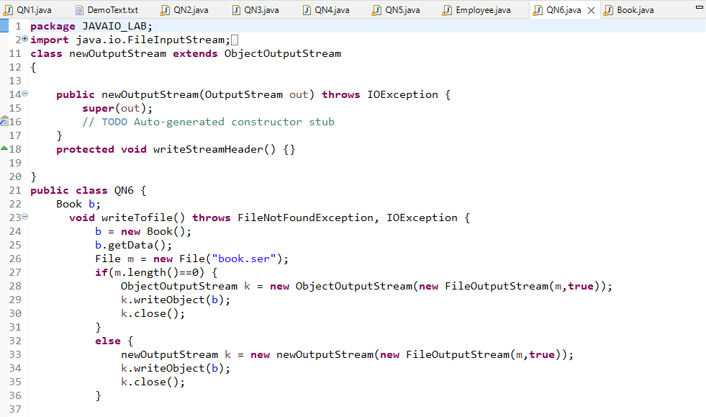

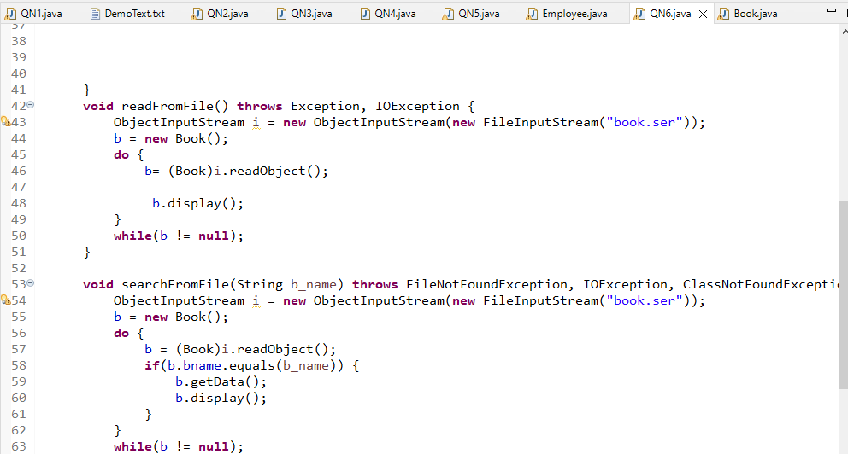

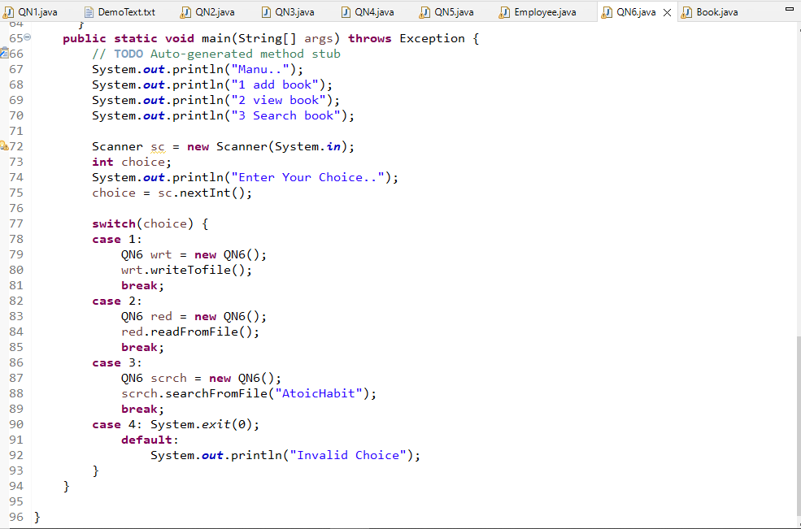

Output

